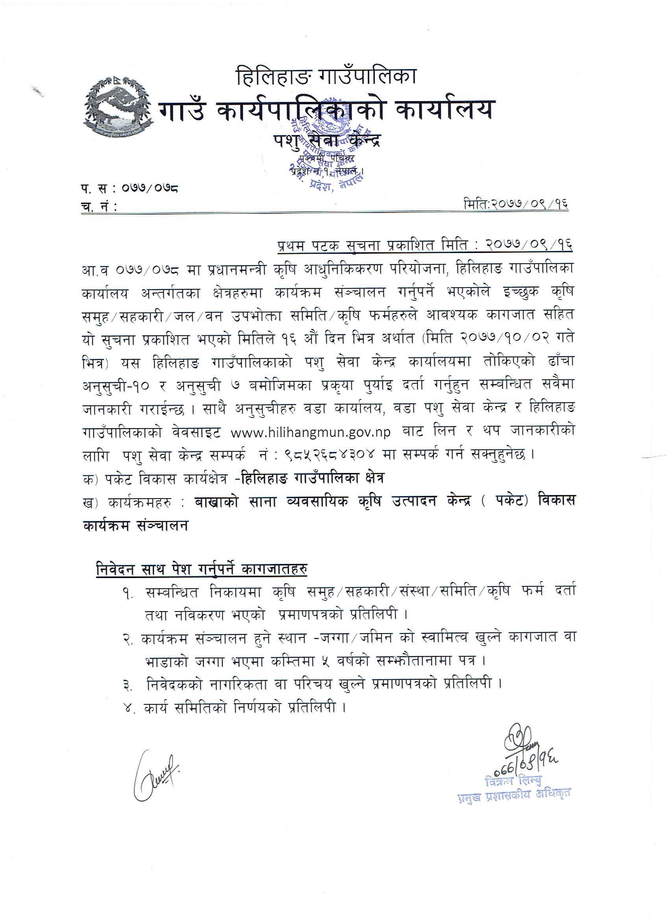

cg';'rL – &

-kl/R5]b $ sf] $=!=* -s_ $=!=!=# v –O_ $=@=* -s_ / $=@=!# v –O_ ;+u ;DalGwt _

ks]6÷Jns If]q dfusf] nflu cfwf/e't tYofªs kmf/d

!= k|:tfljt ks]6÷Jns ljsf; x'g] jflnsf] gfd M

@=k|:tfljt ks]6 ÷Jns ljsf; ul/g] :yfg M

#= k|:tfljt ks]6÷ Jns If]qdf kl/of]hgf cGtu{t ;+~rfng e} ;s]sf ks]6÷Jnssf] ljj/0f

|  |  |  |  |  |
| --- | --- | --- | --- | --- |
| ks]6÷Jns ;~rfng ePsf] jfln÷j:t' | ufpFkflnsf ÷gu/kflnsf | j8f gDa/ | ks]6÷Jnssf] If]qkmn-x]S6/ _ | ks]6÷Jns ;+~rfngsf] cjlw |
|  |  |  |  |  |
|  |  |  |  |  |

-$_ k|:tfljt ks]6÷Jns If]q cGtu{t sfo{qmddf ;dfj]; x'g ;Sg] 3/w'/Lx?sf] ljj/0f

|  |  |  |
| --- | --- | --- |
| ufpFkflnsf ÷gu/kflnsf | j8f gDa/ | nlIft s[ifs 3/w'/L ;+Vof |
|  |  |  |

-%_ k|:tfljt ks]6 ÷Jns If]qdf ;dfj]z x'g] v]tL of]Uo hUufsf] ljj/0f

|  |  |  |  |  |
| --- | --- | --- | --- | --- |
| hUufsf] lsl;d | If]qkmn –x]S6/ | l;+lrt –x]S6/ | cl;+lrt – x]S6/ | l;+lrt eP l;+rfOsf] >f]t |
| v]t |  |  |  |  |
| kfvf] |  |  |  |  |
| af/L |  |  |  |  |
| hDdf |  |  |  |  |

-^_ k|:tfljt ks]6÷Jns ;~rfng If]qsf] k|d'v aflnsf] xfnsf] If]qkmn pTkfbg tyf pTkfbsTj ljj/0f

|  |  |  |  |  |
| --- | --- | --- | --- | --- |
| ks]6÷Jns If]qsf] xfnsf] k|d'v jfln j:t'x? | s'n If]qkmn –x]S6/_÷;+vof | pTkfbsTj  d]=6g÷x]S6/ | s'n pTkfbg  d]=6g | cg'dflgt ljlqm kl/df0f –d]=6g_ |
| ax'jlif{o afln |  |  |  |  |
| l;hgn aflnx? |  |  |  |  |
|  |  |  |  |  |
| kz'kfng |  |  |  |  |
| dT:okfng |  |  |  |  |
|  |  |  |  |  |

-&_ k|:tfljt ks]6 ÷Jns sfo{qmdaf6 k|fKt x'g] ck]lIft pknlJwx? – ks]6÷Jns ;+~rfng kZrft k|fKt x'g] pknlJw ljj/0f pNn]v ug]{ .

-s_ kmnkm'b au}+rf

|  |  |  |  |  |  |
| --- | --- | --- | --- | --- | --- |
| hUufsf] If]qkmn | hDdf af]6 ;+Vof | k'0f{ ?kdf pTkfglzn af]6 ;+Vof | xf+lzs pTkfbglxn af]6 ;+Vof | hDdf pTkfbg –d]=6g_ | yk lj:tf/ x'g] If]qkmn –x]S6/ |
|  |  |  |  |  |  |
|  |  |  |  |  |  |

-v_ l;hgn afln

|  |  |  |  |  |
| --- | --- | --- | --- | --- |
| hUufsf] If]qkmn | tf]lsPsf] jflnn] 9fSg] If]qkmn | pTkfbTj –d]=6g k|lt x]S6/ | hDdf pTkfbg | yk lj:tf/ x'g] If]qkmn –x]S6/ |
|  |  |  |  |  |
|  |  |  |  |  |

-u_ k|:tfljt kz'kfng

|  |  |  |  |  |
| --- | --- | --- | --- | --- |
| kz'\kfng | kz'wgsf] ;+Vof | k|lt kz'wg pTkfng –b'w / df;' | hDdf pTkfbg | yk x'g] kz'wg ;+vof |
|  |  |  |  |  |
|  |  |  |  |  |

-3_ k|:tfljt dT:okfng

|  |  |  |  |  |  |
| --- | --- | --- | --- | --- | --- |
| df5fsf] hft | kf]v/L ;+Vof | hnfzo If]qkmn  -x]S6/ _ | pTkfbg –d]=6g_ | pTkfbsTj d]=6g÷x]S6/ | yk x'g] hnf;o If]qkmn –x]S6/ |
|  |  |  |  |  |  |
|  |  |  |  |  |  |

-*_ k|:tfljt ks]6÷Jns df pNn]v ul/Psf] jfl;n÷ j:t'sf] k|fljlws Pj+ ef}uf]lns pko'tmtf

–

–

-(_ k|:tfljt ks]6÷Jns df pNn]v ul/Psf] afln÷j:t'sf] jhfl/s/0fsf] ;Defjgf

|  |  |  |
| --- | --- | --- |
| k|d'v ahf/ | pknJw jhf/ k'jf{wf/ | pTkfngsf] jhfl/s/0f of]hgf |
|  |  |  |
|  |  |  |

-!)_ k|:tfljt ks]6÷Jns ;+~rfng ug{ cfjZos s[lif pTkfbg ;fdlu| pknJwtfsf] >f]t Pj+ cj:yf

|  |  |
| --- | --- |
| pTkfbg ;fdlu| | pknJw >f]t |
|  |  |
|  |  |

-!!_ k|:tfljt ks]6÷Jns cGtu{tsf] jfln a:t'sf] pTkfbgsf] nflu cfjZos s[lif k'jf{wf/x?sf] pknJwtf

–

–

-!@_ k|:tfljt ks]6÷Jns If]q leq ;fd'lxs v]lt jf sn:6/ v]ltsf] xfnsf] cj:yf Pj= lj:tf/sf] ;Defjgf

!#+ k|:tfljt ks]6÷Jns sfof{Gjogaf6 yk x'g ;Sg] /f]hufl/sf cj;/x?

|  |  |  |
| --- | --- | --- |
| cflz+s /f]hufl/ | k'0f{sflng /f]huf/L | b}lgs Hofnfbf/L |
|  |  |  |
|  |  |  |

!$=k|:tfljt ks]6÷Jns ug'{sf cfwf/x? –Go'gtd If]qkmn jf ;+Vof ,;+:yfut Ifdtf ,cfj]bg ;+:yfx?sf] olx k|s[ltsf sfo{qmd ;+~rfng u/]sf] cg'ej cflb

–

–

-!%_ k|:tfljt ks]6÷Jns / jfln÷j:t' 5gf}6 ugf{sf] k'i6ofO{

–

–

!^= k|:tfljt ks]6÷Jns dfu ug]{ ;+:yfsdf] k|f]kmfOn

* ks]6÷Jns dfu ug]{ ;+:yf Ps eGbf al9 eP of] k|f]kmfOn qmdz yk ub}{ hfg]_

s[lif ;d'x÷s[lif ;xsf/L÷;ldlt / s[lif kmd{sf] gfd M

u7g ePsf] ldlt M

;+:yfsf] 7]ufgf M

tkfO+sf] ;d'x÷;+:yf s'g} ;xsf/L ;+:yfdf cfj4 5 eg] ;f] ;+:yfsf]

gfd=========================================================btf{ g+===============================================

s[lif ;d'x÷s[lif ;xsf/L÷;ldlt / s[lif kmd{ s;/L u7g ePsf] xf] . s;sf] u7g eof] ==============================

s[lif ;d'x÷s[lif ;xsf/L÷;ldlt / s[lif kmd{ u7g vf; pw]Zo s] xf] ==============================

dfl;s art 5 jf 5}g .olb 5 eg] slt=======================================

s_ a}+s===============================================================v_ vftf g+============================================

s[lif ;d'x÷;xsf/L ÷;ldlt / s[lif kmd{ sfof{Gjogsf] k|df0f

s_ lg0f{o- _ -v_ gubL vftf - _ -u_ a}+s vftfsf] ljj/0f - _

3_ btf{ k|df0f kq - _ -ª_ crn ;DktLsf] :jfldTjsf] k|df0f kq - _ -r_ cGo eP v'nfpg'xf]; ======================================================= hDdf z]o/ ;+Vof===========================================

s[lif ;d'x÷s[lif ;xsf/L÷;ldlt / s[lif kmd{sf ;b:ox?sf] ljj/0f

|  |  |  |  |
| --- | --- | --- | --- |
| qm=; | ;b:osf] gfd | 7]ufgf | v]lt of]Uo hldg÷kz' ;+Vof |
|  |  |  |  |
|  |  |  |  |

gf]6 M != o; cg';'rLnfO ks]6 / Jns k|f]kmfOn k|of]hgsf] nflu ;d]t k|of]u ul/g]5 .

@= ;DalGwt sfof{non] cfjZostf cg';f/ afln÷a:t' ljif];sf nflu o; cg';'rLnfO lj:t[lts/0f ug{ ;Sg]5 .

cg';'rL–!)

* kl/R5]b $ sf] $=!=(=! –v_ $=@=(=! –v_ $=#=!=! –v_ / $=$=!=! –v_ ;+un ;DalGwt

;'rgfsf nflu cfj]bg kmf/fd –gd'gf_

>L k|d'v Ho' ldltM======================

============================================================

====================================================sfof{no ================================ .

ljifo M ======================================================================================== .

k|:t't ljifodf o; lxlnxfª ufpFkflnsf sfof{noaf6 ldlt==================================df k|sflzt ;fj{hlgs ;'rgf adf]lhd cfjZos sfuhft ;lxt xfd|f] ;d'x÷;xsf/L÷;+:yf÷s[lif kmd{sf ;b:ox?n] ============================================sfo{qmd cGtu{t=============================-lqmofsnfkx? gfd_;+~rfrng ug{ OR5's ePsf]n] ;xeflu u/fO lbg'x'g of] lgj]bg k]z u/]sf] 5'÷5f}+ .

lgj]bs

==================================

|  |  |  |  |  |  |
| --- | --- | --- | --- | --- | --- |
| qm=; | s[ifs ;d'x leq /x]sf nfeflGjt s[ifssf] gfd y/ | 7]ufgf | klt÷kTgLsf] gfd | ;Dks{ g+ | b:tvt |
|  |  |  |  |  |  |
|  |  |  |  |  |  |

lgj]bg ;fy ;+nUg sfuhftx?

-^_ ;DAlGwt lgsfodf s[lif ;d'x÷;xsf/L÷;+:yf÷;ldlt÷s[lif kmd{ btf{ tyf gljs/0f ePsf] k|df0fkqsf] k|ltlnkL .

-&_ sfo{qmd ;+~rfng x'g] :yfg –hUuf ÷hldg _ sf] ljj/0f jf ef8fsf] hUuf ePdf slDtdf % jif{sf] ;Demf}tfgfdf .

-*_ lgj]bssf] gful/stf jf kl/ro v'Ng] k|df0fkqsf] k|ltlnkL .

-(_ sfo{ ;ldltsf] lg0f{osf] k|ltlnkL .\

**lgj]bg ;fy ;+nUg ug'{kg]{ tYofªs kmf/fdsf] 9fFrf**

efu ! s[lif ;d'x÷;xsf/L÷;+:yf ÷;ldtL / s[lif kmd{sf] ljj/0f

!= s[lif ;d'x ÷;xsf/L÷;+:yf ÷;ldtL ÷s[lif kmd{sf] gfd M

@=s[lif ;d'x÷;xsf/L ÷;+:yf ÷;ldlt÷s[lif kmd{sf] u7g ePsf] ldlt M

#= s[lif ;d'x÷;xsf/L ÷;+:yf ÷;ldlt÷s[lif kmd{sf] 7]ufgf M

$= tkfOsf] ;d'x ÷;+:yf s'g} ;/sf/L ;+:yfdf cfj4 5 eg] ;f] ;:yfsf]

gfd===================================================================btf {g+ =========================================

%= s[lif ;d'x÷;xsf/L÷;+:yf÷;ldlt÷s[lif kmd{ s;/L u7g ePsf] xf] . s;sf] ;xof]udf s[lif ;d'x÷;xsf/L÷;+:yf÷;ldlt÷s[lif kmd{ u7g eof] .

^=s[lif ;d'x÷;xsf/L÷;+:yf ÷;ldlt÷s[lif kmd{ u7g vf; pw]Zo s] xf] .==========================================================

&= dfl;s art 5 jf5}g .olb 5 eg] slt=========================================

s_ a}+s==================================================================v_ vftf g+ ======================================

*= s[lif ;d'x÷;xsf/L÷;+:yf÷;ldlt÷s[lif kmd{ sfof{Gjogsf] k|df0f

s_ lg0f{o - _ v_ gulb vftf - _ -u_ a}+s vftfsf] ljj/0f- _

3_ btf{ k|df0f kq - _ ª_ crn ;Dkltsf] :jfldTjsf] k|df0f kq - _

r_ cGo eP v'nfpg'xf];\====================================================

(=s[lif ;d'x÷;xsf/L÷;+:yf÷;ldtL÷s[lif kmd{ ;b:otfsf] ljj/0f

|  |  |  |  |  |  |
| --- | --- | --- | --- | --- | --- |
| qm=; | ;b:osf] gfd | lnªu | klt÷kTgLsf] gfd | v]ltof]Uo hldg÷kz' ;+Vof | s}lkmot |
|  |  |  |  |  |  |

efu @ k|:tfljt lqmofsnfk

!= sfo{qmdsf] lzif{s M

@= sfo{qmdsf] k'/f ljj/0f M

#= sfo{qmdsf] dxTj M

$=sfo{qmdaf6 x'g] kmfObf M

%= sfo{qmdaf6 :yflgo cj;/x?sf] s;/L k|of]u x'G5

^=s[lif ;d'x÷;xsf/L÷;+:yf÷;ldlt÷s[lif kmd{af6 o:tf lqmofsnfkx? klxNo} ePsf] 5 jf 5}g

s_ % - _ -v_ 5}g - _

&= k|:tfljt sfo{qmdaf6 ;j} cyjf afx'Notf ePsf ;d'x÷;xsf/L ÷;+:yf÷;ldlt ;b:o s;/L nfeflGjt x'G5

*= jftfj/l0fo b[li6sf]0faf6 pko'tm eP gePsf]

efu # cfly{s kIf

!= k|:tfljt sfo{qmdsf] cg'dflgt s'n nfut M

@= ;d'x÷;xsf/L÷;+:yf÷;ldlt÷kmd{sf] cfkm\gf] of]ubfg ?

#=============================sfof{noaf6 dfu u/]sf] cg'bfg /sd ?

$= k|:tfljt sfo{qmdsf] cg'dflgt nfut ljj/0f

%= k|:tfljt lqmofsnfk sfof{Gjog of]hgf

* cfjZos ;/–;fdfg sxfF / s;/L 5gf}6 ug]{
* s:tf] k|sf/sf] ;/–;fdfg sf] dfkm{t k|fKt ug]{
* kl/of]hgfaf6 pTkfbg x'g] jf;ln÷j:t'sf] jhf/Ls/0f s;/Lx'g]
* >d tyf >d nfut Joj:yfkg s;/L ug]{
* cGo ljj/0f